PIZZA SALES SQL QUERIES

A.KPI’S

1.Total Revenue

SELECT SUM(TOTAL_PRICE) AS REVENUE FROM PIZZA_SALES;

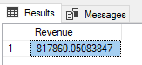

2.Average Order Value

SELECT ROUND(SUM(TOTAL_PRICE)/ COUNT (DISTINCT ORDER_ID),4) AS AVG_ORDER_VALUE FROM PIZZA_SALES;

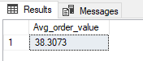

3.Total Pizzas Sold

SELECT COUNT(QUANTITY) AS TOTAL_PIZZA_SALES FROM PIZZA_SALES;

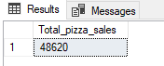

4.Total Orders

SELECT COUNT(DISTINCT ORDER_ID) AS TOTAL_ORDERS FROM PIZZA_SALES;

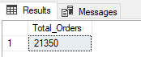

5.Average Pizzas per Order

SELECT CAST(CAST(SUM(QUANTITY)AS DECIMAL(10,2))

/CAST (COUNT(DISTINCT ORDER_ID)AS DECIMAL(10,2)) AS DECIMAL(10,2)) AS AVG_PIZZA_ORDERS FROM PIZZA_SALES;

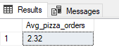

PROBLEM STATEMENT

1.Daily Trends on Total Orders

select DATENAME (DW, order_date) as order_day,count(distinct order_id) as total_orders from pizza_sales group by DATENAME (DW ,order_date) ;

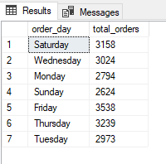

2.Hourly Trends on Total Orders

SELECT DATEPART (HH, ORDER_TIME) AS ORDER_HOURS,COUNT(DISTINCT ORDER_ID) AS TOTAL_ORDERS_PER_HOUR

FROM PIZZA_SALES GROUP BY DATEPART (HH ,ORDER_TIME) ORDER BY ORDER_HOURS ;

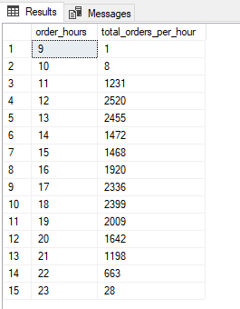

D.% of Sales by Pizza Category

SELECT PIZZA_CATEGORY,SUM(TOTAL_PRICE) AS TOTAL_SALES,CAST(SUM(TOTAL_PRICE)*100/ (SELECT SUM(TOTAL_PRICE) FROM PIZZA_SALES)AS DECIMAL(10,2))

AS PERCNTG_TOTAL_SALES FROM PIZZA_SALES

GROUP BY PIZZA_CATEGORY ;

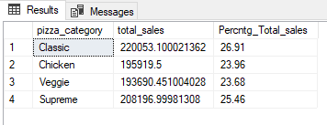

E.% of Sales by Pizza Size

select pizza_size,sum(total_price) as total_sales,cast(sum(total_price)*100 / (select sum(total_price) from pizza_sales )as decimal(10,2))

as Percntg_Total_sales from pizza_sales

group by pizza_size

order by pizza_size;

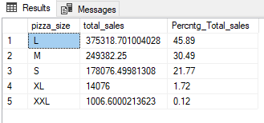

F. Total Pizza sold by Pizza Category

SELECT PIZZA_CATEGORY, SUM(QUANTITY)AS TOTAL_QUANTITY_SOLD FROM PIZZA_SALES WHERE MONTH(ORDER_DATE)=2

GROUP BY PIZZA_CATEGORY ORDER BY TOTAL_QUANTITY_SOLD DESC ;

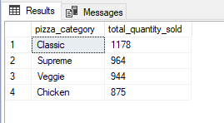

G.Top 5 Best Sellers by Total Pizzas Sold

SELECT TOP 5 PIZZA_NAME,SUM(QUANTITY)AS TOTAL_QUANTITY_SOLD FROM PIZZA_SALES GROUP BY PIZZA_NAME ORDER BY TOTAL_QUANTITY_SOLD DESC;

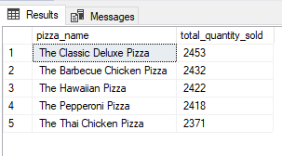

H. Bottom 5 Best Sellers by Total Pizzas Sold

SELECT TOP 5 PIZZA_NAME,SUM(QUANTITY)AS TOTAL_QUANTITY_SOLD FROM PIZZA_SALES GROUP BY PIZZA_NAME ORDER BY TOTAL_QUANTITY_SOLD ASC;

